CHAPTER 1
COMPANY PROFILE

SAI-TEC
A novel approach towards technology


1.1 COMPANY PROFILE

SAI-TEC is a company with professionals teamed up to offer the quality solutions for R & D activities. Our professionals are experts and are proven team leaders in Hardware industry. Our vision, technologies, tools, information, organization methods and mind-sets have emphasized on performance and high quality standards.

1.2 RESEARCH
Our mission is to contribute to for high-performance computing applications. This is done through exploration of new system designs and organizations, circuits, and design tools and methodologies. A key goal is to continue to drive innovative exploratory ideas into real products.

1.2.1 CURRENT AREAS OF RESEARCH
- Image Processing: Watermarking, Stenography, Cryptography, Compression, Biometric Information, Motion Detection, Trucking & Recognition, Gesture Recognition.
- Cloud Computing and Big Data analytics: Software as a Service (SaaS), Platform as a Service(PaaS) and Infrastructure as a Service (IaaS).

1.3 VLSI DESIGN

- FPGA Debugging Using Chip Scope Pro.
- Embedded Design Using Xilinx EDK Embedded Android.
- Using SDK for Software/application Development.
- VGA interfacing using ML403 FPGA.
- System Generator Debugging Complex Designs.
- Memory Designs for ASIC based Processors.
- MATLAB Simulink Interface to FPGA.

1.4 EMBEDDED SYSTEM

- Boot loader Development.
- BSP development for RTOS.
- Porting RTOS to suite a different hardware platform.
- Porting applications from one RTOS or hardware to another.
- Developing Communication stacks (including CAN, Bluetooth, TCP/IP, and more).
- Embedded System application development.
- Embedded software testing.

1.5 PRODUCTS

Sai Tech offer product development services from concept to deployment; covering various aspects like product conceptualization, architecture and system design, initial development, application deployment and feature enhancement.

SAI-TEC has come up with some products as follows:
1. FPGA Based Real time Fingerprint Device.
2. Embedded Voting machine based on Biometric Features.
3. Intelligent Robot for Real time applications.
4. Vehicle Tracking System.

1.6 DESIGN AND VERIFICATION SERVICES

- SAI-TEC provides a wide range of Hardware and Software services.
- Hardware design and development services include FPGA hardware design.
- ASIC prototyping.
- Hardware board design.

1.7 SOME OF OUR CILENTS

1. Complaint Management System Police Commissioner Office, Bangalore.
2. Android Based Mobile Development Pushkala Technologies.
3. Hospital management System JSS Speech and Hearing Hospital, Dharwad.

1.8 TRAINING
- SIA-TEC is a company which is concentrating on different technological domains which can enhance the practical knowledge of students working with experienced professionals from reputed industries and academic experts to suit the industrial requirements.
- SAI-TEC is constantly involved in conducted training program to engineering graduates to meet the industrial requirements. The different training programs and workshops conducted are
- VLSI -Front End and Back end Design.
- Embedded System Design using ARM Cortex M3
- Embedded system Design using Raspberry PI.
- Embedded Android using Begal Bone.
- Embedded C and Optimisation using Industry standard
- Image Processing using MATLAB.
- Image Processing using OpenCV on Beagalboard.

1.9 SERVICES
SIA-TEC is a company with a team of doctorates, experienced technical academicians and talented young engineers who can assist to complete challenging academic projects related to recent IEEE publications using following methodology.
- Literature Survey and Problem Statement.
- Training on related Domains
- Module Level Design and Testing.
- Implementation of System / Algorithm.
- Testing and Validation.
- Assistance for Project documentation.
- Paper presentation in National/International Conferences and International Journals.

1.10 Domains
- VLSI Design.
- Embedded System Design.
- Image Processing using MATLAB.
- Image Processing using BegalBoard
- Embedded Android.
- Communication and Networking.
- Wireless / Adhoc Networks.

CHAPTER 2
DEPARTMENT

Sai-tec has different departments like VLSI, Embedded and Image processing. I am working under VLSI department. Intern will be trained on Hardware description language especially on Verilog. RTL design and verification using Verilog is more concentrated division.

I work in VLSI front design department where coding is done using Xilinx 14.2 tool.other platforms of Xilinx that is system generator, EDK, SDK, Chipscope and planahead is also thought.

2.1 VLSI DESIGN

- FPGA Debugging Using Chip Scope Pro.
- Embedded Design Using Xilinx EDK Embedded Android.
- Using SDK for Software/application Development.
- VGA interfacing using ML403 FPGA.
- System Generator Debugging Complex Designs.
- Memory Designs for ASIC based Processors.
- MATLAB Simulink Interface to FPGA.

2.2 DESIGN AND VERIFICATION SERVICES

- SAI-TEC provides a wide range of Hardware and Software services.
- Hardware design and development services include FPGA hardware design.

- ASIC prototyping.
- Hardware board design.

2.3 PRODUCTS

- Sai Tech offer product development services from concept to deployment; covering various aspects like product conceptualization, architecture and system design, initial development, application deployment and feature enhancement.

SAI-TEC has come up with some products as follows:
- 1. FPGA Based Real time Fingerprint Device.
- 2. Embedded Voting machine based on Biometric Features.
- 3. Intelligent Robot for Real time applications.
- 4. Vehicle Tracking System.

CHAPTER 3

DESIGN AND VERIFICATION ENVIRONMENT FOR AMBA BUS PROTOCOL FOR SOC INTEGRATION USING SYSTEM GENERATOR

3.1 Abstract:

Microprocessor performance has improved in recent years. In result, of which memory access time is increased that limits the system performance. The memory controller is the part of the system that will controls the memory read and write operations. It manages the flow of data going to and from the computer’s (processor’s) main memory. The Advanced microcontroller bus architecture (AMBA) is a open specification for the management of functional blocks comprising system-on-chips (SOCs). System-on-chip is an integrated circuit which integrates all parts of a processor into a single chip. This project shows the design details of AMBA high performance (AHB) bus with the memory controller interface for the application of image transfer and the resultant efficiency in respect of speed is provided. The realization of this architecture is based on the concept of conventional finite state machines (FSMs). Here AHB BUS is implemented using system generator. The memory controller designed using AHB bus is synthesized into black box using simulink system generator. The image transfer is implemented by using simulink and xilinx gateway blocks. Memory controller is the part of the system that controls memory and generates the necessary signals to control the reading and writing of information from and to the memory, and interfaces the memory with the other major parts of the system.

3.2 Software Requirement

- Development environment used : Xilinx
- Software version : licensed version 14.5 ISE
- Language used: verilog
- Operating system: windows 7

3.3 Objective of the study
In the earlier system, the data transfer is done by the processor or by the peripherals itself. The peripherals will do data transfer very slowly. And if the data transfer is done by the processor then a lot of CPU time is wasted in doing the data transfer. A processor needs to interact with other processors, memories or input/output devices to complete a task. Currently, bus systems are used to interconnect the intellectual property (IP) blocks. A major problem is to deal with large amount of data storage. The dynamic memories have high data rates and large storage capabilities. In order to allow efficient communication between the IP blocks and a shared memory requires the use of a memory controller.

The task given by sai-tec is to develop the proposed system, an Advanced Microcontroller Bus Architecture (AMBA) compliant memory controller is designed for system memory control for the application of the image transfer. The target of this project is to design an MC that will provide high performance and high frequency for efficient communication between the IP blocks and memory. The image transfer is done using system generator by combining serialization and deserialization of the image with the black box of the memory controller.

3.4 TRANING DESCRPITION
3.4.1 INTRODUCTION TO VLSI
VLSI: Minimum of 10 lakh components on maximum of 5µm chip area. To perform specific
Function, it can be analog, digital or mixed function.

VLSI CLASSIFICATION BASED ON FUNCTION:-
- Analog
- Digital
- Mixed
3.4.2 VLSI CLASSIFICATION BASED ON METHODOLOGY:-

- ASIC:-Application specific integrated chip
- FPGA:-Field programmable gate array.

    - FUNDAMENTALS OF CMOS:-
CMOS is a complementary metal oxide semiconductor device. The word semiconductor is used because pmos and nmos will not be ‘on’ at the same time. Hence power consumption is reduced by 50%.
PMOS source is connected to VDD always because it works with negative voltage, to create that Negative voltage source of pmos is connected to the VDD. NMOS source is connected to VSS always because it works with positive voltage, to create that positive voltage source of nmos is connected to the VSS.
This can be seen in the figure below will represents a simple two input logical nand gate.
Gate terminal is used create path in MOS and Drain is responsible for movement of chargers.
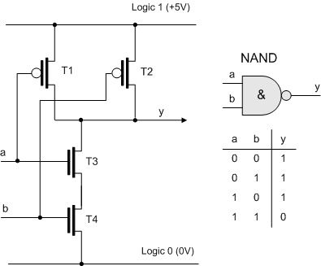
Fig 3.4.3.1 Logical NAND gate

    - VLSI DESIGN FLOW:-
Front end design: Virtual design logical verification, working on simulator.(top level to simulate and verify).
Back end design: From complier to the FPGA dumping comes under back end design, working on physical things.
Fig 3.4.4.1 VLSI design flow

3.4.5 BASICS OF DIGITAL CIRCUITS

3.4.5.1 Digital circuits
- Digital logic systems can be classified as combinational or sequential.
  - Combinational circuits can be completely described by the truth table.
  - Sequential systems contain state stored in memory elements internal to the system. Their behavior depends both on the set of inputs supplied and on the contents of the internal memory, or state of the system. Thus, a sequential system cannot be described with a truth table. Instead, a sequential system is described as a finite-state machine (or often just state machine).
3.4.5.2 Combinational circuits
- Output depends on the present inputs.
- Example: gates, encoder, decoder, mux.
- Combinational circuits works according to there rule, example if AND gate is design for 1ns we have to work in that if we want 2ns its not possible.
- Fixed delay, we don’t have control over it
3.4.5.3 Sequential circuits
- Output depends on present input and previous output. Feedback and clock present in sequential circuits.
- Example : flip-flops, counter, shift register .
- We can decide own delay
- Moore machine sequential circuit: The next output depends only on the present state output.
- Mealy machine sequential circuit: The next state output depends on the present state as well as input both state .flip-flop is the example.
      - Calculation of total clock period for sequential circuit
- Definition of setup and hold time, calculation of total clock period required for the circuit proper operation.
- Setup time:-The data arriving at flipflop should be stable before the arrival of clock.Time required by data to become stable is setup time.
- Hold Time:- Time for the data to get settle down after the positive/negative edge of clock.
- Many problem examples on this topic is solved by referring to the Text book “Digital system design using VHDL” by CHARELS H.ROTH.

    - MODELING OF FSM
3.4.6.1 FSM (Finite State Machine)
- A finite state machine has a set of states and two functions called the next-state function and the output function
  - The set of states correspond to all the possible combinations of the internal storage If there are n bits of storage, there are 2^{n} possible states
  - The next state function is a combinational logic function that given the inputs and the current state, determines the next state of the system
- When the sequence of actions in your design depend on the state of sequential elements, a finite state machine (FSM) can be implemented
- FSMs are widely used in applications that require prescribed sequential activity
  - Example:
    - Sequence Detector
    - Fancy counters
    - Traffic Light Controller
    - Data-path Controller
    - Device Interface Controller etc.
For non-technical clients putting the problem definition in the Xilinx language, then FSM is required with state diagram to build the chip.
- FSM is used for optimization of power.
- The output function produces a set of outputs from the current state and the inputs
  - There are two types of finite state machines
  - In a Moore machine, the output only depends on the current state
  - While in a Mealy machine, the output depends both the current state and the current input
  - We are only going to deal with the Moore machine.
  - These two types are equivalent in capabilities
- All state machines have the general feedback structure consisting of:
- Combinational logic implements the next state logic
- Next state (ns) of the machine is formed from the current state (cs) and th current inputs
- State register holds the value of current state.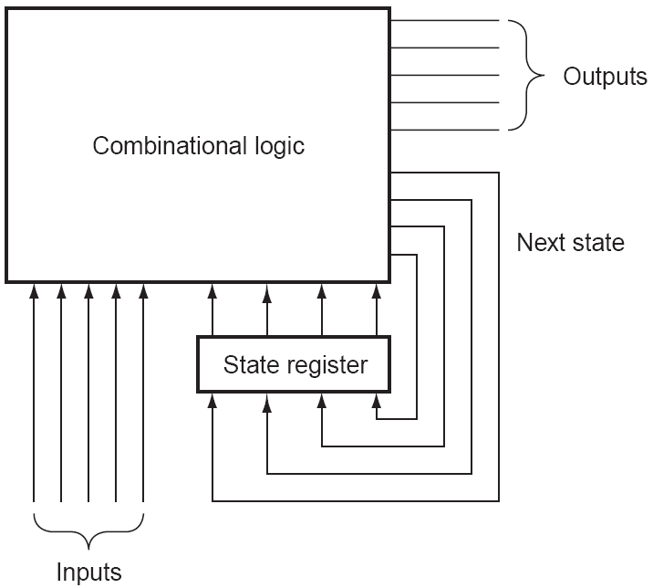
Fig 3.4.6.1.1 sequential circuits
Next-State
Logic
Memory
Inputs
Current
State
Next State
Fig 3.4.6.1.2 FSM using state register
3.4.6.2 Types of State Machines
3.4.6.2.1 Moore State Machine
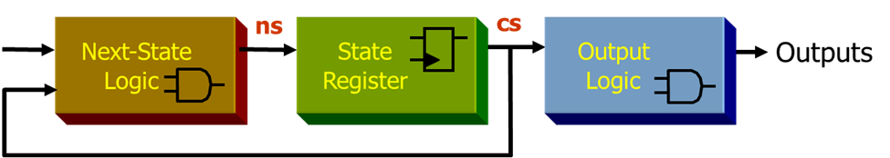
Fig 3.4.6.2.1.1 Moore machine
- Next state depends on the current state and the inputs but the output depends only on the present state
  - next state(t) = h(current state(t), input(t))
  - output = g(current state(t))
3.4.6.2.2 Mealy state machine
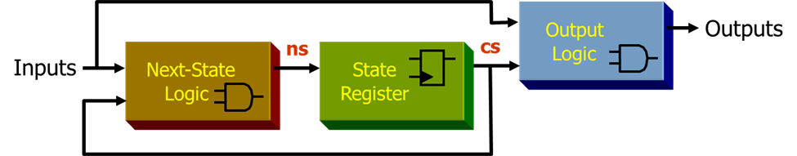
Fig 3.4.6.2.2.1 Mealy machine

3.4. 7 Introduction to VLSI Design
3.4.7.1 Hardware Descriptive Language
Used to describe a digital system
  - For example, a network switch, a microprocessor or a memory or a simple flip-flop.
  - Using a HDL, one can describe any (digital) hardware at any level.
  - HDL’s execute concurrently.
3.4.7.2 Verilog: Verify logic
- Verilog is relatively simple and close to C
- Verilog has 60% of the world digital design market (larger share in US)
- Verilog is case sensitive (Keywords are in lowercase)
- Easy implementation
- Verilog HDL allows a hardware designer to describer designs at a high level of abstraction such as at the architectural or behavioral level as well as the lower implementation levels(i.e., gate and switch levels).
      - VHDL: Very high speed integrated circuit Hardware Descriptive Language.
- VHDL is complex and close to Ada.
3.4.7.4 Verilog Coding Types
- Dataflow
- describes how the signal flows from system inputs to outputs.
- Behavioral
- describes the system by showing how the outputs behave according to changes in the input.
- Structural: describes the logical components of a system.
3.4.7.5 Test Bench and Simulation Types
Test bench and Verilog code design done in Xilinx 14.5
- Full adder.
- Mux 2:1, 4:1, 8:1.
- Up counter, down counter, up down counter.
- D flip-flop, SR latch, JK flip-flop.
- 8:3 Encoder and decoder.
- Sequence detector.
  - TECHNICAL SPECIFICATION OF AMBA PROTOCOL AND SYSTEM GENERATOR.
    - AMBA PROTOCOL
The Advanced Microcontroller Bus Architecture (AMBA) specification defines an on chip communications standard for designing high-performance embedded microcontrollers.
Three distinct buses are defined within the AMBA specification:
• Advanced High-performance Bus (AHB)
• Advanced System Bus (ASB)
• Advanced Peripheral Bus (APB).
A test methodology is included with the AMBA specification which provides an infrastructure for modular macro cell test and diagnostic access.

3.5.1.1 Advanced High-performance Bus (AHB)

The AMBA AHB is for high-performance, high clock frequency system modules.The AHB acts as the high-performance system backbone bus. AHB supports the efficient connection of processors, on-chip memories and off-chip external memory interfaces with low-power peripheral macrocell functions. AHB is also specified to ensure ease of use in an efficient design flow using synthesis and automated test techniques
.
3.5.1.2 Advanced System Bus (ASB)

The AMBA ASB is for high-performance system modules. AMBA ASB is an alternative system bus suitable for use where the high-performance features of AHB are not required. ASB also supports the efficient connection of processors, on-chip memories and off-chip external memory interfaces with low-power peripheral macro cell functions.

3.5.1.3 Advanced Peripheral Bus (APB)

The AMBA APB is for low-power peripherals. AMBA APB is optimized for minimal power consumption and reduced interface complexity to support peripheral functions. APB can be used in conjunction with either version of system bus.

Fig 3.5.1.3.1 General AMBA block diagram.

3.5.2 Introducing the AMBA AHB

AHB is a new generation of AMBA bus which is intended to address the requirements of high-performance synthesizable designs. It is a high-performance system bus that supports multiple bus masters and provides high-bandwidth operation. AMBA AHB implements the features required for high-performance, high clock frequency systems including:-

• Burst transfers
• Split transactions
• Single-cycle bus master handover
• Single-clock edge operation
• Non-tristate implementation
• Wider data bus configurations (64/128 bits).

Bridging between this higher level of bus and the current ASB/APB can be done efficiently to ensure that any existing designs can be easily integrated. An AMBA AHB design may contain one or more bus masters, typically a system would contain at least the processor and test interface. However, it would also be common for a Direct Memory Access (DMA) or Digital Signal Processor (DSP) to be included as bus masters. The external memory interface, APB bridge and any internal memory are the most common AHB slaves. Any other peripheral in the system could also be included as an AHB slave. However, low-bandwidth peripherals typically reside on the APB.

A typical AMBA AHB system design contains the following components:

AHB master A bus master is able to initiate read and write operations by providing an address and control information. Only one bus master is allowed to actively use the bus at any one time.

AHB slave A bus slave responds to a read or write operation within a given address-space range. The bus slave signals back to the active master the success, failure or waiting of the data transfer.
AHB arbiter the bus arbiter ensures that only one bus master at a time is allowed to initiate data transfers. Even though the arbitration protocol is fixed, any arbitration algorithm, such as highest
Priority or fair access can be implemented depending on the application requirements. An AHB would include only one arbiter, although this would be trivial in single bus master systems.

AHB decoder The AHB decoder is used to decode the address of each transfer and provide a select signal for the slave that is involved in the transfer. A single centralized decoder is required in all AHB implementations.

3.5.2.1 When to use AMBA AHB
A full AHB is used for:
• Bus masters
• On-chip memory blocks
• External memory interfaces

3.5.2.2 BURST OPERATION
Four, eight and sixteen-beat bursts are defined in the AMBA AHB protocol, as well as undefined-length bursts and single transfers. Both incrementing and wrapping bursts are supported in the protocol:
• Incrementing bursts access sequential locations and the address of each transfer in the burst is just an increment of the previous address.
• For wrapping bursts, if the start address of the transfer is not aligned to the total number of bytes in the burst (size x beats) then the address of the transfers in the burst will wrap when the boundary is reached. For example, a four-beat wrapping burst of word (4-byte) accesses will wrap at 16-byte boundaries. Therefore, if the start address of the transfer is 0x34, then it consists of four transfers to addresses 0x34, 0x38, 0x3C and 0x30.
Bursts must not cross a 1kB address boundary. Therefore it is important that masters do not attempt to start a fixed-length incrementing burst which would cause this boundary to be crossed. It is acceptable to perform single transfers using an unspecified-length incrementing burst which only has a burst of length one.
HBURST[2:0] Type Description
000 SINGLE Single transfer
001 INCR Incrementing burst of unspecified length
010 WRAP4 4-beat wrapping burst
011 INCR4 4-beat incrementing burst
100 WRAP8 8-beat wrapping burst
101 INCR8 8-beat incrementing burst
110 WRAP16 16-beat wrapping burst
111 INCR16 16-beat incrementing burst

Tabel 3.5.2.2.1 Burst operation
3.5.3 SYSTEM GENERATOR
System Generator is a DSP design tool from Xilinx that enables the use of the Math Works model-based Simulink design environment for FPGA design. Designs are captured in the DSP friendly Simulink modeling environment using a Xilinx specific block set. All of the downstream FPGA implementation steps including synthesis and place and route are automatically performed to generate an FPGA programming file.

3.5.3.1DSP BLOCK SET
Over 90 DSP building blocks are provided in the Xilinx DSP blockset for Simulink. These blocks include the common DSP building blocks such as adders, multipliers and registers. Also included are a set of complex DSP building blocks such as forward error correction blocks, FFTs, filters and memories. These blocks leverage the Xilinx IP core generators to deliver optimized results for the selected device.
Fig 3.5.3.1.1 DSP BLOCK SET

3.5.3.2 Hardware Co-Simulation
System Generator provides accelerated simulation through hardware co-simulation. System Generator will automatically create a hardware simulation token for a design captured in the Xilinx DSP blockset that will run on one of over 20 supported hardware platforms. This hardware will co-simulate with the rest of the Simulink system to provide up to a 1000x simulation performance increase.
Fig 3.5.3.2.1 Hardware co-simulation
3.5.3.3 System Integration Platform
System Generator provides a system integration platform for the design of DSP FPGAs that allows the RTL, Simulink, MATLAB and C/C++ components of a DSP system to come together in a single simulation and implementation environment. System Generator supports a black box block that allows RTL to be imported into Simulink and co-simulated with either ModelSim or Xilinx®

ISE® Simulator. System Generator also supports the inclusion of a MicroBlaze® embedded processor running C/C++ programs.
Fig 3.5.3.3.1 System integration platform

  - LITERATURE SURVEY
3.6.1 BUS ENCODING ALGORITHM FOR AMBA
Advanced microcontroller bus architecture (AMBA) is rapidly becoming the de facto standard for new system-on-chip (SoC) designs. The bus protocol is complex, making any peripherals that can interface to it valuable intellectual property (IP). This paper presents a low power bus encoding architecture which is able to deal with the complex advanced high performance bus (AHB) protocol within AMBA, which involves multiple burst transfers. The architecture is targeted for a low-power SoC platform to be used in a miniaturized low power application area. The paper describes the SoC platform and the bus encoding architecture, and provides results with a design synthesized at 0.35 mm CMOS technology indicating up to 22% power saving.

For generic SOC platform the best bus encoding technique is bus invert technique. In addition, its implementation leads to much less complex hardware for both decoding and encoding logic. When using bus-invert for data coding an extra bit, known as the invert, is required. When the invert bit is set to 0 the value of the data bus is equal to the original data, and when it is set to 1 the data on the bus is equal to the inverse of the original data.

This paper concluded that implementation bus invert technique on data bus consumes less power than the data bus without bus invert technique[1].

Fig 3.6.1.1 Power consumption with and without bus-invert.

    - AHB DDR SDRAM Enhanced Memory Controller
Memory controllers are designed in order to reduce the memory access time which has remained as a memory bottleneck which limits the system performance. In this design it shows how to design and implement an Enhanced Memory Controller with high performance AMBA AHB-Lite interface native DDR SDRAM controller. The memory controller features a modular design, fully optimized in terms of resources with pipelined architecture suitable for high-speed operation. All AMBA AHB-Lite protocol transfers are fully supported. Because of AMBA protocol usage it can be easily integrated into any SoC design. Implementation of Enhanced Memory Controller is carried out using VHDL coding and simulation is modeled with MODEL SIM. Memory controller is integrated in to a FPGA board in order to carry out the memory transactions.
Fig 3.6.2.1 Memory controller design
Memory controller provides the necessary address commands and control signals necessary for DDR to perform the READ and write operation. Memory controller successfully decodes the AHB transactions effectively and delivers the data based on this. There is no loss of data or control information. Memory controller implemented above support AMBA AHB protocol with internal data bus width up to 64 bits. Since AMBA AHB bus protocol is a universal protocol this memory controller architecture can be used on any FPGA device[3].

3.6.3 Building an AMBA AHB compliant Memory Controller
Microprocessor performance has improved rapidly these years. In contrast, memory latencies and bandwidths have improved little. The result is that the memory access time has been a bottleneck which limits the system performance. Memory controller (MC) is designed and built to attacking this problem. The memory controller is the part of the system that, well, controls the memory. The memory controller is normally integrated into the system chipset. This paper shows how to build an Advanced Microcontroller Bus Architecture (AMBA) compliant MC as an Advanced High-performance Bus (AHB) slave. The MC is designed for system memory control with the main memory consisting of SRAM and ROM[2].

Fig 3.6.3.1 Architecture of AHB MC

3.6.4 Design and Implementation of High-Performance Master/Slave Memory Controller

The on-chip interconnection system known as advanced microcontroller bus architecture (AMBA) is a well-established open specification for the proper management of functional blocks comprising system-on-chips (SOCs). Here, the design and implementation details of AMBA high-performance bus (AHB) master and slave with memory controller (MC) interface are discussed. A bridge between AHB master and slave with supportive application of MC is also proposed and the resultant efficiency in respect of area overhead and speed is provided. The realization of the control structure is based on the concept of conventional finite state machines (FSMs). The intellectual property (IP) blocks of AHB master and slave are implemented on a XilinxSpartan3 field programmable gate array (FPGA) chip (3s50pq208-5).

An AHB-based MC is designed, realized and tested here. The implementation was carried out using Verilog HDL for SOC solutions. The design has taken care of balance between area overhead and speed. The master has been implanted and its address generator block is synthesized with a single adder instead of typical 64 adders. The design has been realized following a modular approach. To avoid handshaking complexity, we have used the FIFO for the MC and slave interface. Even though this increases the latency, it makes design simple and free of bottleneck. The design has been synthesized on Xilinx 13.1 Spartan3 and simulated in ModelSim[4].
  - METHODOLGY
3.7.1 Objective of the study
- To design memory using AMBA Bus specification.
- The memory with AMBA has to be used for transfer of an image and display.
- To integrate preprocessing components of system generator with protocol AMBA and implement on FPGA.

    - MEMORY DESIGNING
A RAM memory is designed with width ‘8’ and depth ‘256’.As on RAM both data can be written and read individual read and write and simultaneous read and write is possible. To design simultaneous read and write different address for read and write is used. Write enable and read enable signals are used to enable the operation. These enable signals are generated depending on controller unit.
ALGORITHM FOR RAM:
Wr= write enable
Rd=read enable
Rd_addr= read address
Wr_addr=write address
If(wr=0 rd=1)
Data_out=mem[rd_addr];
Else if(wr=1&rd=0);
Mem[wr_addr]=data;
Else if(wr=1 &rd=1)
Mem[wr_addr]=data;
Data_out=mem[rd_addr];

The code is designed using Xilinx ISE 14.5 and simulated using Isim simulator.When hready=1 in controller unit then rst for memory unit is generated.

Write operation
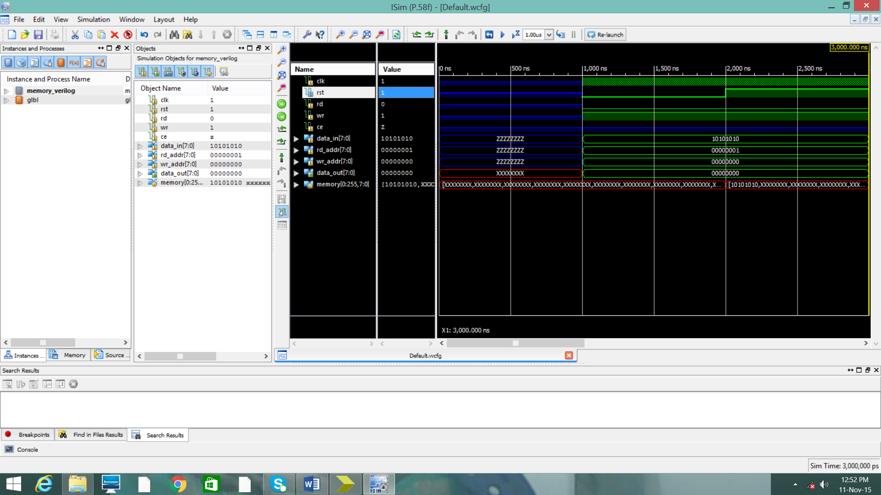
Fig 3.7.2.1 WRITE operation
When rst=1 ,data_out=0 and when rst=1,wr=1 and rd=0,data_in is written into memrory specified by write address.When hwrite=1 in controller unit then wr=1 in memory unit

READ operation
The data in memory specified by the read address is written into data_out. Wr=0 and rd=1and rst=1.when hread=1 in controller unit then rd=1 in memrory unit.
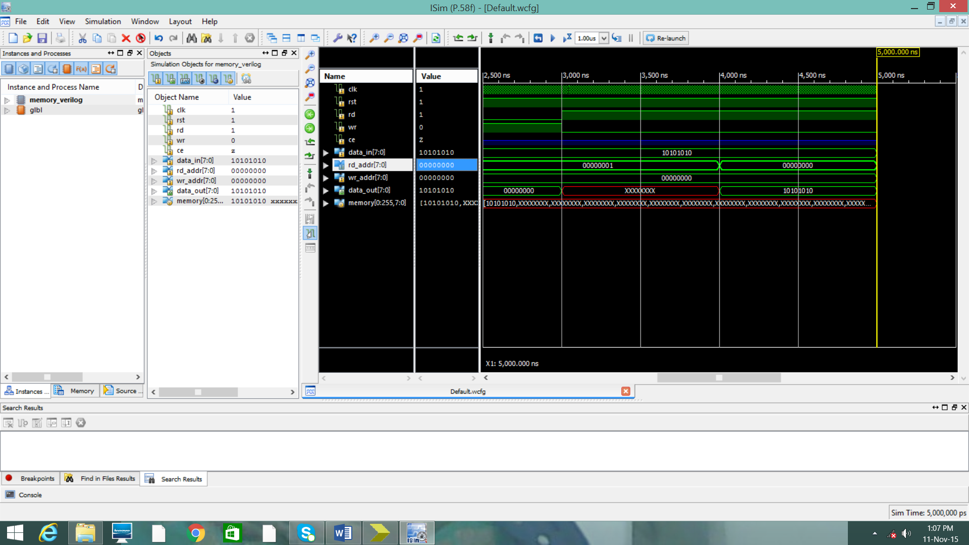
Fig 3.7.2.2 READ operation

SIMULTANEOUS READ AND WRITE OPERATION
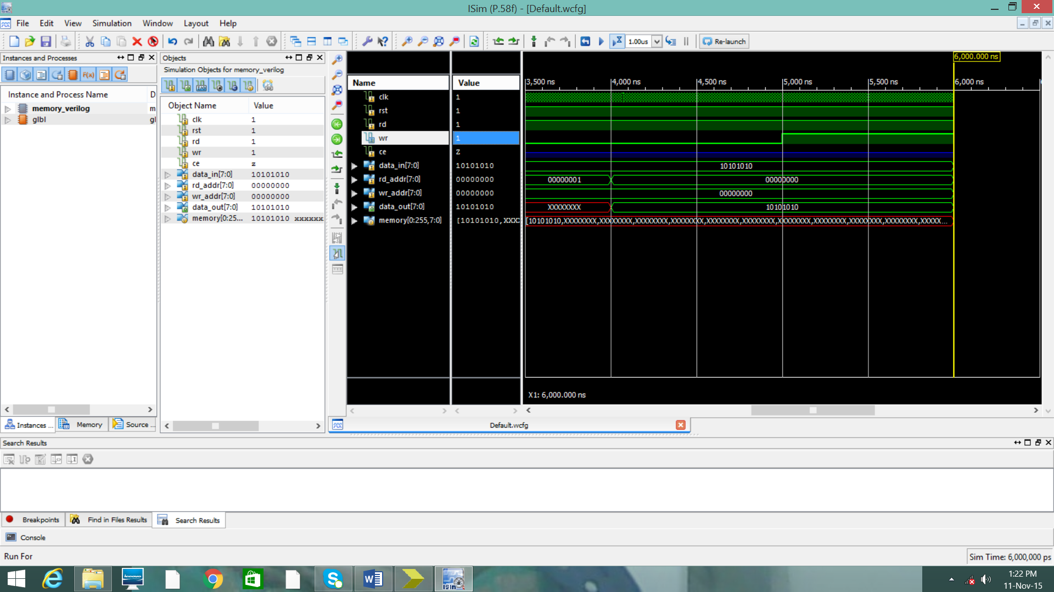
Fig 3.7.2.3 Simultaneous read and write
When rst=1,wr=1 and rd=1 simultaneously data is written and read from memory.hready=1,hwrite=1 and hread=1 in control unit simultaneous read write is possible.

  - CONTOLLER UNIT
Controller unit will generate the reset, write enable and read enable signals for memory unit depending on Hready ,Hwrite and Hread signals. The state diagram for controller unit has five states.Start, ready, write,read,write error and read error are the five states. The state diagram is shown below.
Fig 3.8.1 CONTROLLER UNIT
The HDL code is written according to the state diagram in Xilinx ISE 14.5 and simulated using ISim simulator. The algorithm for the code is written as below.
ALGORITHM for controller unit:
Initial state =start;
Start:
If(hready==1)
State=ready
Else
State=start;

Ready:
If(hwrite==1)
State=write;
Else if(hread==1)
State=read;
Else
State=ready;

Write:
If(wr=1 and rd=0)
Write operation
State=start;
Else
State=write error;

Read:
If(wr=0 and rd=1)
Read operation
State=start;
Else
State=read error;

Write_error
If(wr=1 and rd=0)
State=write;
Else if(wr=0&rd=1)
State=ready;
Else
State=write_error;

Read_error:
If(wr=0&rd=1)
State=read;
Else if(wr=1&rd=0)
State=write;
Else
State=read_error;

  - Proposed model
Fig 3.9.1 Proposed model

The controller unit is connected to the memory unit and they are synchronized with the common clock. Hready, Hwrite and Hread signals are used to generate the control signals of the memory unit and the algorithm for it is shown below which is included in the start state of controller algorithm.
start:
begin
if(hready==1 && hread==0 && hwrite==0)
begin
rd_out<=1'b0;
wr_out<=1'b0;
rst_out<=1'b1;
state<=ready;
end
else if(hready==1 && hread==0 && hwrite==1)
begin
rd_out<=1'b0;
wr_out<=1'b1;
rst_out<=1'b1;
state<=write;
end
else if(hready==1 && hread==1 && hwrite==0)
begin
rd_out<=1'b1;
wr_out<=1'b0;
rst_out<=1'b1;
state<=read;
end
else if(hready==1 && hread==1 && hwrite==1)
begin
rd_out<=1'b1;
wr_out<=1'b1;
rst_out<=1'b1;
state<=start;
end
else
begin
rd_out<=1'b0;
wr_out<=1'b0;
rst_out<=1'b0;
state<=start;
end
end

  - BLACK BOX
Once the code is written in Xilinx ISE 14.5 it simulated in Isim simulator and checked for its proper functionality. The synthesized and simulated code in Xilinx is the converted black box in system generator. After converting it to black box the required input signals is given and then simulated in system generator. Once the simulation output is obtained hardware is generated and the code is dumped into the kit.
Step 1: Start Simulink in system generator and open the design file.
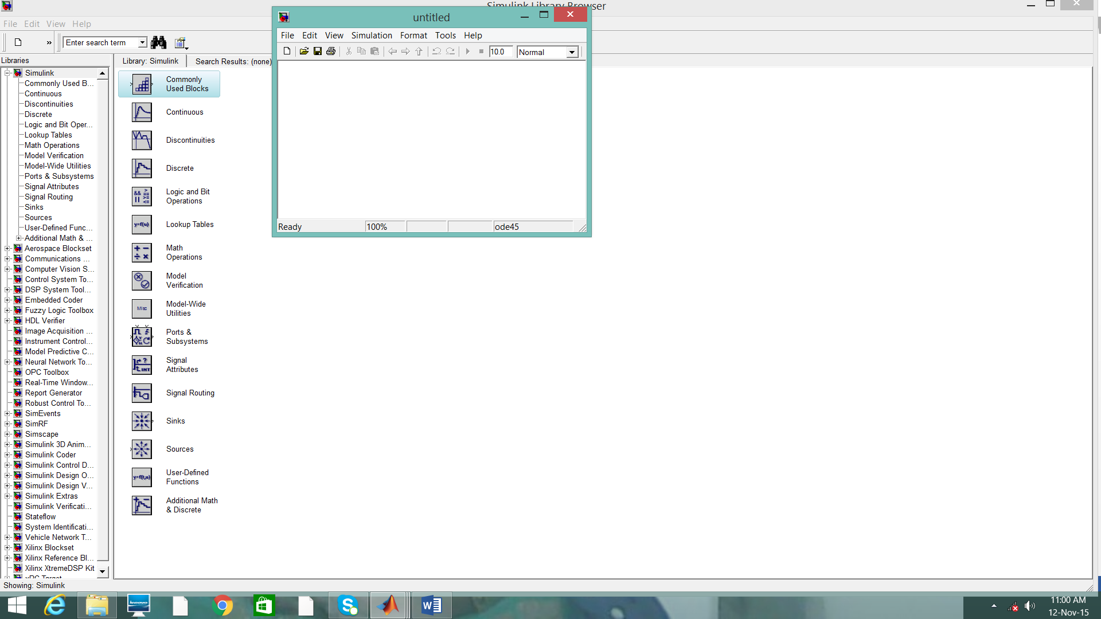
Fig 3.10.1 Generating mdl file

Step 2:Create new. mdl file and save it in the folder where the Xilinx code of the model id saved.
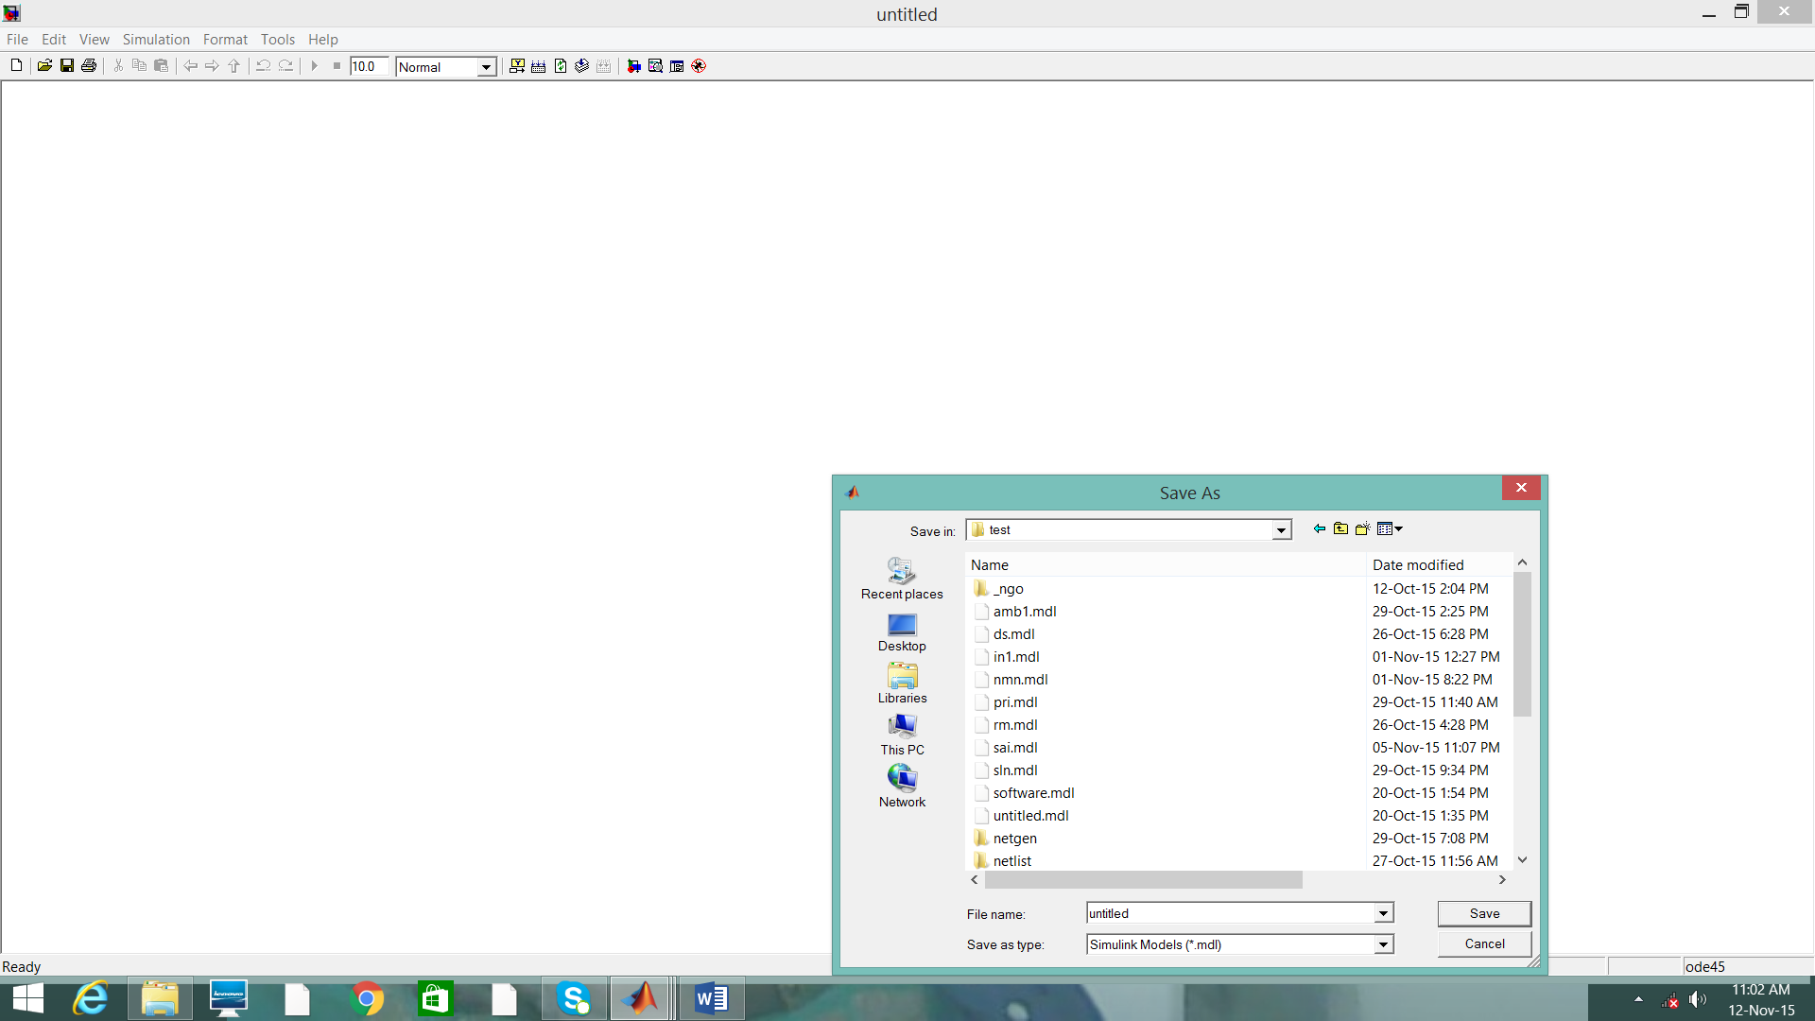
Fig 3.10.2 Saving mdl file
Step 3:Drag and drop the black box from the Xilinx "Basic Elements" library into the model
Select required .v file in the folder for the top-level HDL file and click Open.
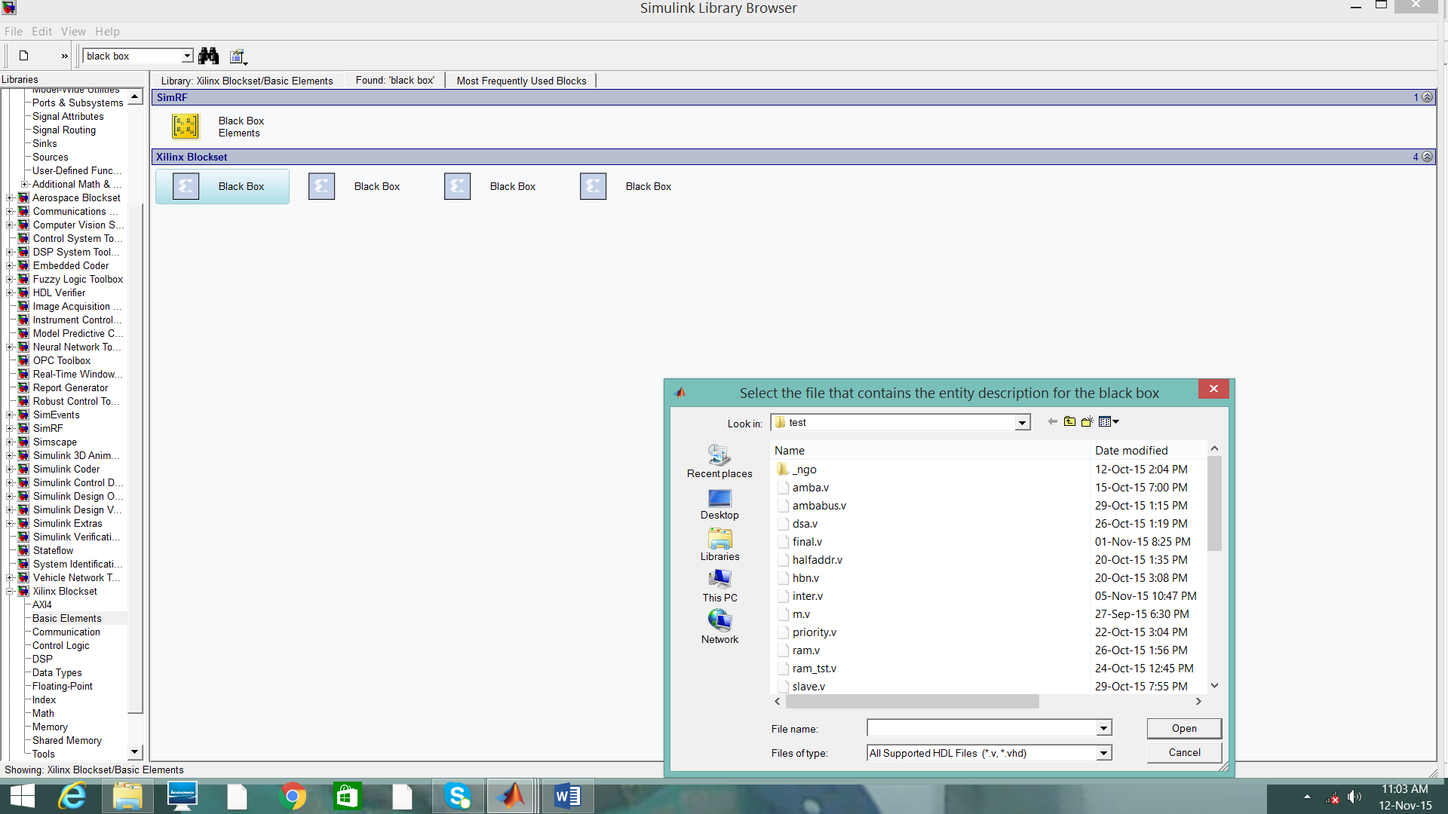
Fig 3.10.3 Creation of black box

Step 4: BLACK box is generated and configuration file for the code is also automatically generated. As shown in figure.
Fig 3.10.4 Configuration file
Step 5: Make the required connection using other blocks in system generator library as shown in the fig 3.10.2
Step 6:Add system generator token to the model.
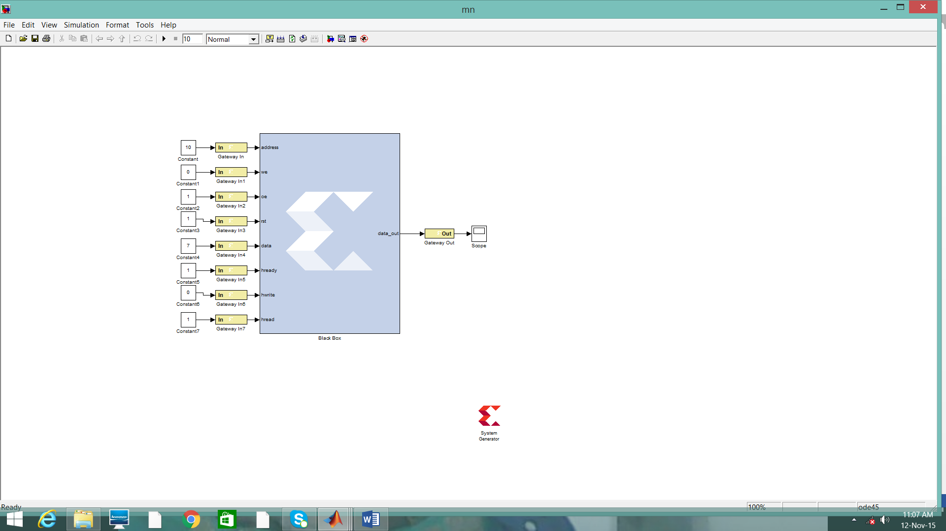
F ig 3.10.5 Connections to black box

Step 7: change the simulator in black box property from inactive to ISE simulator as shown in fig 3.10.3
Fig 3.10.6 Changing the properties of Black box

Step 8:Then simulate the code.
Step 9:Make required changes according hardware used in system generator token and generate hardware and dump it using Ethernet port as it bidirectional port.

CHAPTER 4

SPECIFIC OUTCOMES

  - OBJECTIVE OF THE STUDY
- To design memory using AMBA Bus specification.
- The memory with AMBA has to be used for transfer of an image and display.
- To integrate preprocessing components of system generator with protocol AMBA and implement on FPGA.

  - RESULTS OF DESIGN

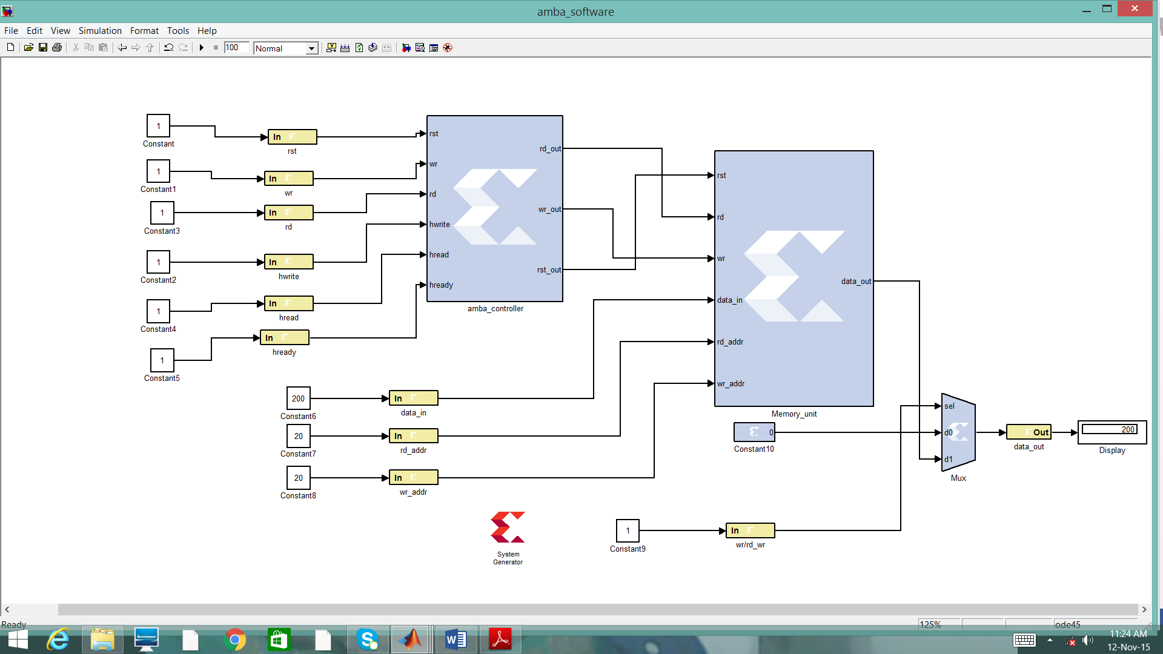
Fig 4.2.1 Implementation of proposed system in Xilinx

Implementation of proposed system in system generator is shown above. Controller unit will control the memory unit by generating control signals. The data in transmitted to the output as the write address and read address is same. The data _out is not connected to the display instead it is connected to the mux just to have a low power design. That is if are just writing data into the memory and no need to display then select line has to be pull downed. Whenever we need to display data then select line is pulled up.

After simulation the hardware model is generated while dumping the code on the board.This done by changing system generator token properties according to board properties.

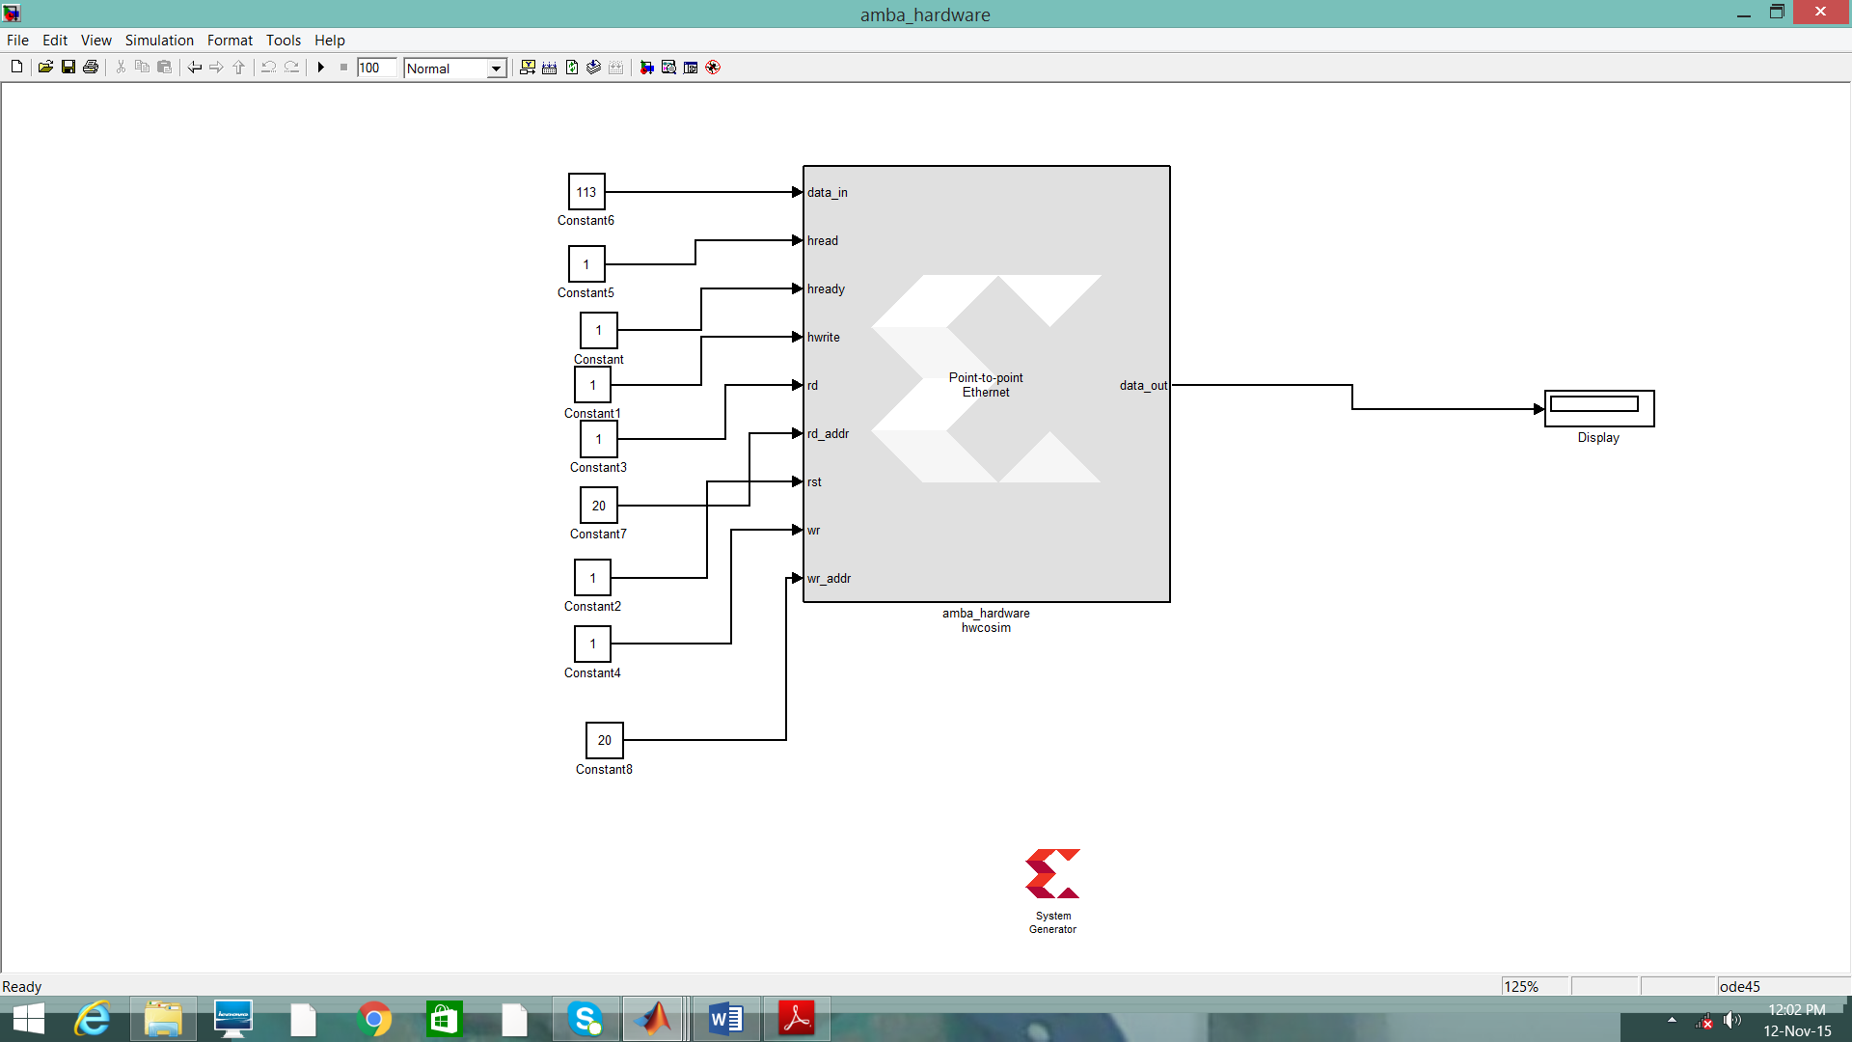

Fig 4.2.2 Hardware implementation model
  - Image Transfer
Now above application is altered for Image application with some extra Simulink blocks added at the data input.

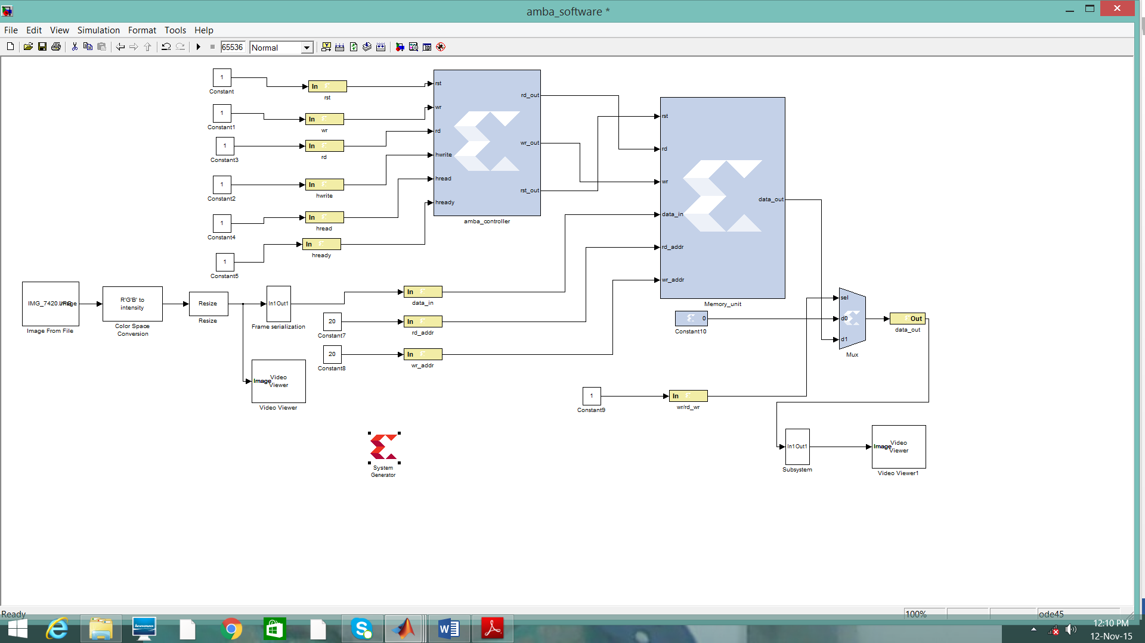
Fig 4.3.1 Image transfer
The image is read from the file the selected image can be browsed through properties of image read from file block. Then the image is converted to gray scale from RGB. That image is resized. serialization operation is performed. At the output the image is reserialized again the same input image is displayed. The simulation time must be 256X256.Time requied to transmit all pixels.
The output image will be gray scaled image as it is converted at the input.
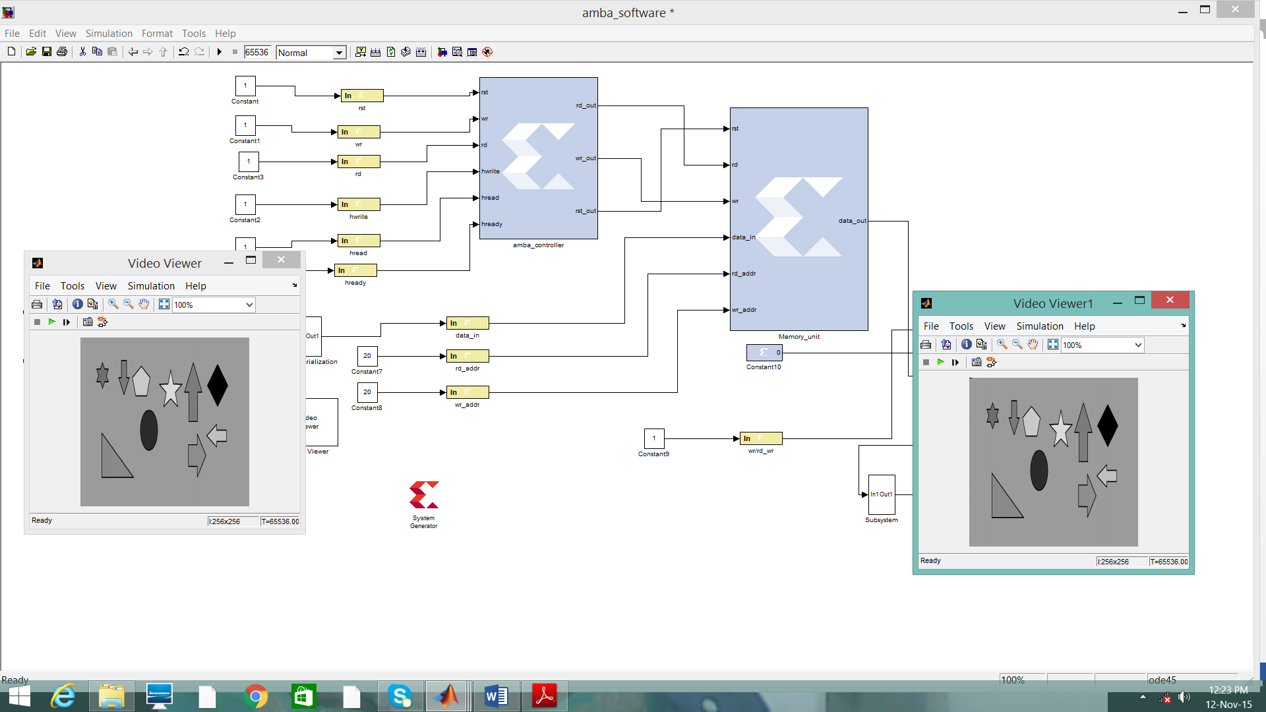
Fig 4.3.2 Image transfer results
Video viewer is the input image that is transferred and video viewer 1 is the received images.
After this simulation the Hardware model is designed for it.
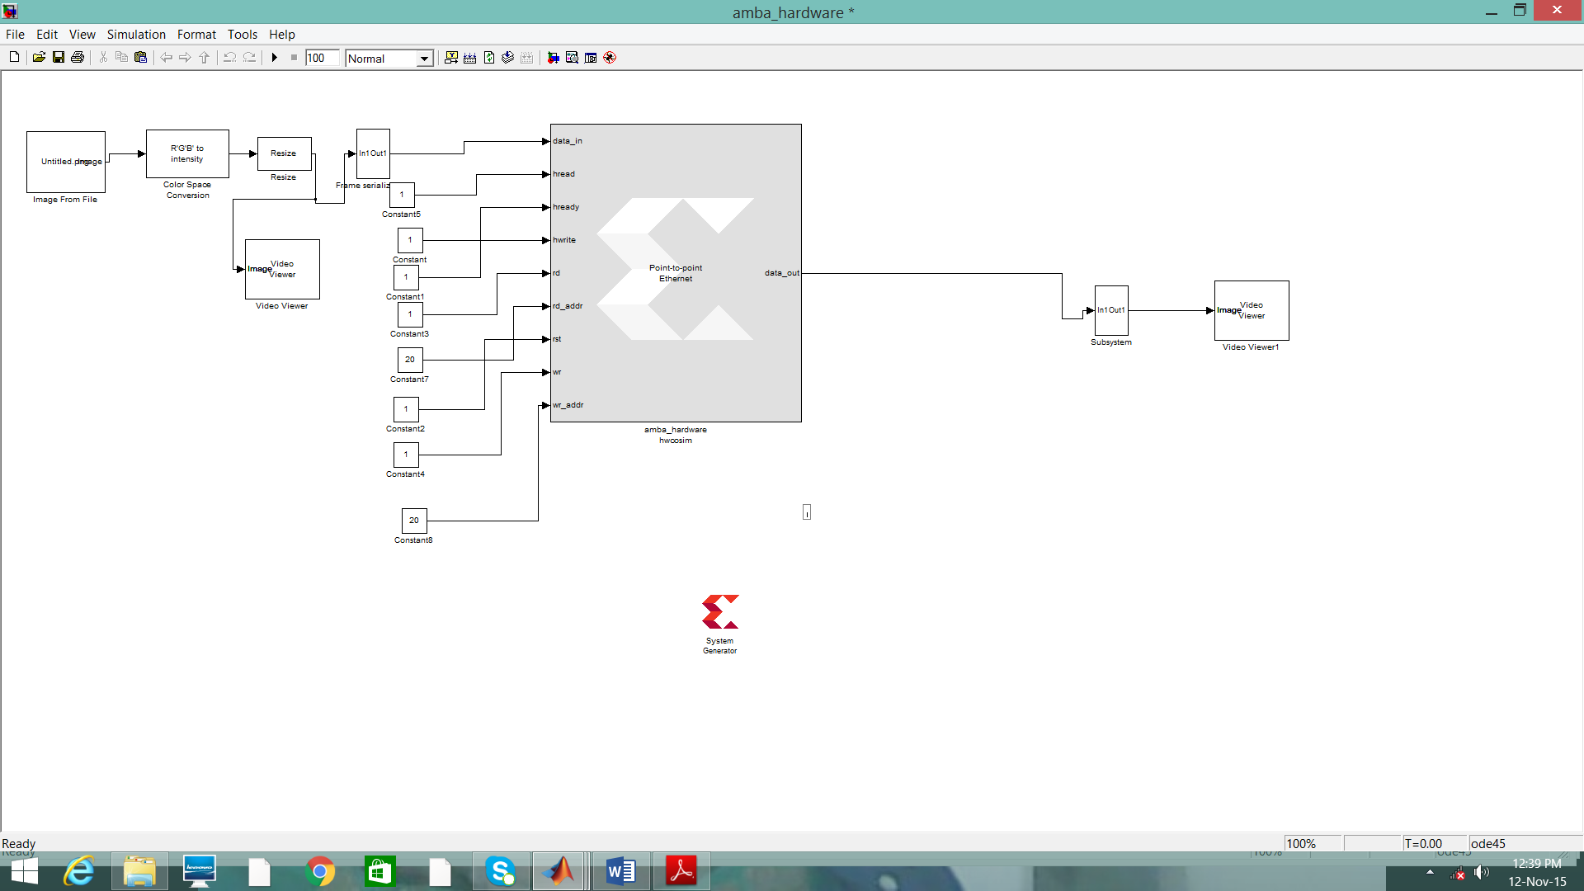
Fig 4.3.3 Hardware mode
  - REFLECTIONS
During the internship of four months detailed RTL designing and verification were thought. HDL
Languages like VHDL and VERILOG were thought. More importance was given to Verilog language. We were trained on all below aspects.

- All the data types operates from the basics were thought.
- Different type of coding style like dataflow, behavioral and structural were thought.
- Dataflow example
module simple_and(a, b, c);
input a;
input b;
output c;
assign c= a & b;
endmodule
- Behavioral example
module ex_counter (clk,rst,count);
input clk,rst;
output [31:0] count;
reg [31:0] count;
always @(posedge clk)
begin
if(rst)
count= 32’b0;
else
count=count+1;
end
endmodule

- Structural example
module system(a, b, sum, cout);
input a, b;
output sum, cout;
xor X1(sum, a, b);
and A1(cout, a,b);
endmodule
- Usage of blocking and non-blocking assignments.
- Non-blocking statements are used model sequential design and blocking model are used to design combinational design.
1.always@ Blocks
always@ blocks are used to describe events that should happen under certain conditions. They are always followed by a set of parentheses, a begin, some code, and an end. Program shows a syntax
always@ block.
Program The skeleton of an always@ block
always @( ... sensitivity list ... ) begin
... elements ...
end
The contents of the always@ block, namely elements describe elements that should be set when the sensitivity list is “satisfied.” For now, just know that when the sensitivity list is “satisfied,” the elements inside the always@ block are set/updated. They are not otherwise. Elements in an always@ block are set/updated in sequentially and in parallel, depending on the type of assignment used. There are two types of assignments: <= (non-blocking) and (blocking).

2. <= (non-blocking) Assignments
Non-blocking assignments happen in parallel. In other words, if an always@ block contains multiple <= assignments, which are literally written in Verilog sequentially, you should think of all of the assignments being set at exactly the same time. For example, consider Program.
Program <= assignments inside of an always@ block
always @( ... sensitivity list ... ) begin
B <= A;
C <= B;
D <= C;
end
Program specifies a circuit that reads “when the sensitivity list is satisfied, B gets A’s value, C gets B’s old value, and D gets C’s old value.” The key here is that C gets B’s old value, etc (read: think OLD value. This ensures that C is not set to A, as A is B’s new value, as of the always@ block’s execution. Non-blocking assignments are used when specifying sequential logics.

3. = (blocking) Assignments
Blocking assignments happen sequentially. In other words, if an always@ block contains multiple = assignments, you should think of the assignments being set one after another. For example, consider Program circuit that reads “when the sensitivity list is satisfied, B gets A, C gets B, and D gets C.” But, by the time C gets B, B has been set to A. Likewise, by the time D gets C, C has been set to B, which, as we stated above, has been set to A. This always@ block turns B, C, and D into A. Blocking

- assignments are used when specifying combinational logic
- Designing of FSM, FIFO and Memories.
- FSM design
we will need a way to express the following in Verilog:

1. A state encoding for each state.
2. A mechanism for keeping track of the current state.
3. Transitions from state to state.
4. Output values based on the current state.
Sequential Circuit Description
- Input Equations
- State Table
- State Diagram
Mealy and Moore Models
- Preceding Example: Output depends on present state and input. This is called the Mealy Model
- Another kind of circuit: Output only depends on present state. This is called the Moore Model

- System generator tool and usage of Simulink block sets.
- Usage of Xilinx block set.
- Introduction to Digital Circuits
- Distinguish between ASIC and FPGA Design flow
- Compare the architecture of FPGA’s and CPLD’s of various classes
- Describe the basic FPGA design flow
- Illustrate the process of implementing a design on Programmable Logic Device (FPGA or CPLD) and addressing the implementation challenges
- Optimize the implemented design with respect to design specifications
- Introduction to VLSI Design Using Xilinx FPGAs.
- Test Bench and Simulation Types.
- I/O planning.

- Design Creation Basics
- The System Generator Design Flow
- The Xilinx DSP Blockset
- Defining the FPGA Boundary
- Adding the System Generator Token
- Creating the DSP Design
- Generating the HDL Code
- Model-Based Design using System Generator
- Creating Input Vectors using MATLAB

- Fixed Point and Bit Operations

- Fixed-Point Numeric Precision
- System Generator Fixed-Point Quantization
- Overflow and Round Modes
- Bit-Level Operations
- The Reinterpret Block
- The Convert Block
- The Concat Block
- Slice Block
- The BitBasher Block

- System Control

- Controlling a DSP System
- The MCode Block
- The Xilinx “xl_state” Data Type
- State Machine Example
- The Expression Block
- Reset and Enable Ports
- Bursty Data

- Multi-Rate Systems

- Creating Multi-Rate Systems
- Up and Down Sampling Blocks
- Rate Changing Functional Blocks
- Viewing Rate Changes in Simulink
- Debugging Tools
- Sample Period “Rules”
- Lab Exercise: Multi-Rate Systems

- Using Memories

- Block vs. Distributed RAM
- Initializing RAMs and ROMs
- System Generator RAM Blocks
- System Generator ROM Blocks
- The Delay Block
- The FIFO Block
- Shared Memory Block

- Designing Filters
- Introduction
- The Virtex DSP48 Math Slice
- FIR Compiler Block
- Creating Coefficients with FDA Tool
- Using FDA Tool Coefficients

At Sai-Tec each intern was given set of design specification and material regarding the specification. We were asked to study the material and design the circuit and we were giving presentations every week regarding progress in the work. So we could work on our communication skills. It was a very good opportunity to build our skills to the industry standard. We even got exposed to the industrial standard of coding and verification.

REFERENCES

[1] Bus encoding architecture for low-power implementation of an AMBA-based SoC platform, IEE Proc.-Comput. Digit. Tech., Vol. 149, No. 4, July 2002.
[2] Building an AMBA AHB compliant Memory Controller, Third International Conference on Measuring Technology and Mechatronics Automation, 2011.
[3] AHB DDR SDRAM Enhanced Memory Controller, International Conference on Advanced Computing and Communication Systems (ICACCS -2013), Dec. 19 – 21, 2013.
[4] Design and Implementation of High-Performance Master/Slave Memory Controller with
Microcontroller Bus Architecture, 978-1-4673-6386-0/14/$31.00 ©2014 IEEE.

